**Module 2: Git Assignment – 4**

1. Created master.txt on master branch, staged and committed it

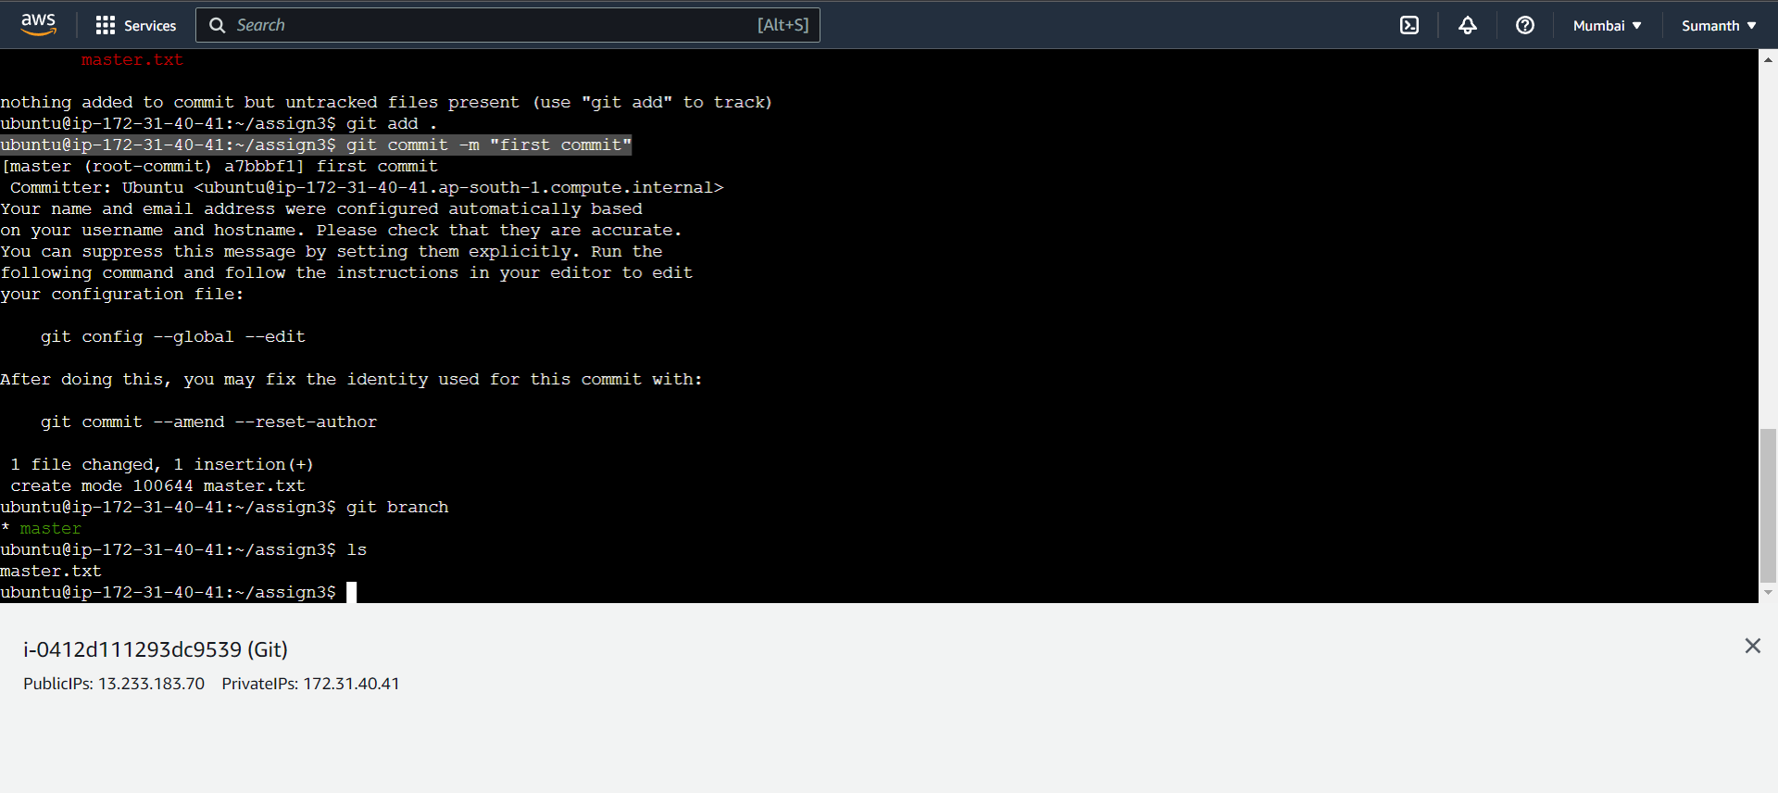

1. Created 3 branches: public1, public2 and private

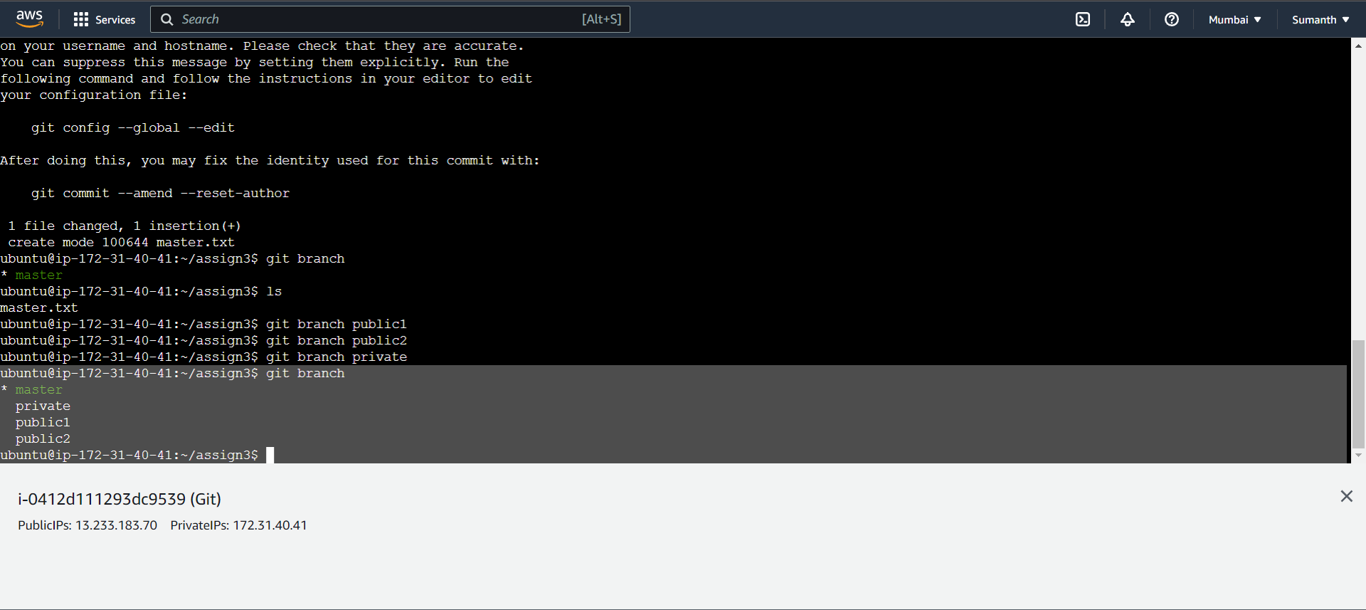

1. Created public1.txt on public1 branch, staged and committed it

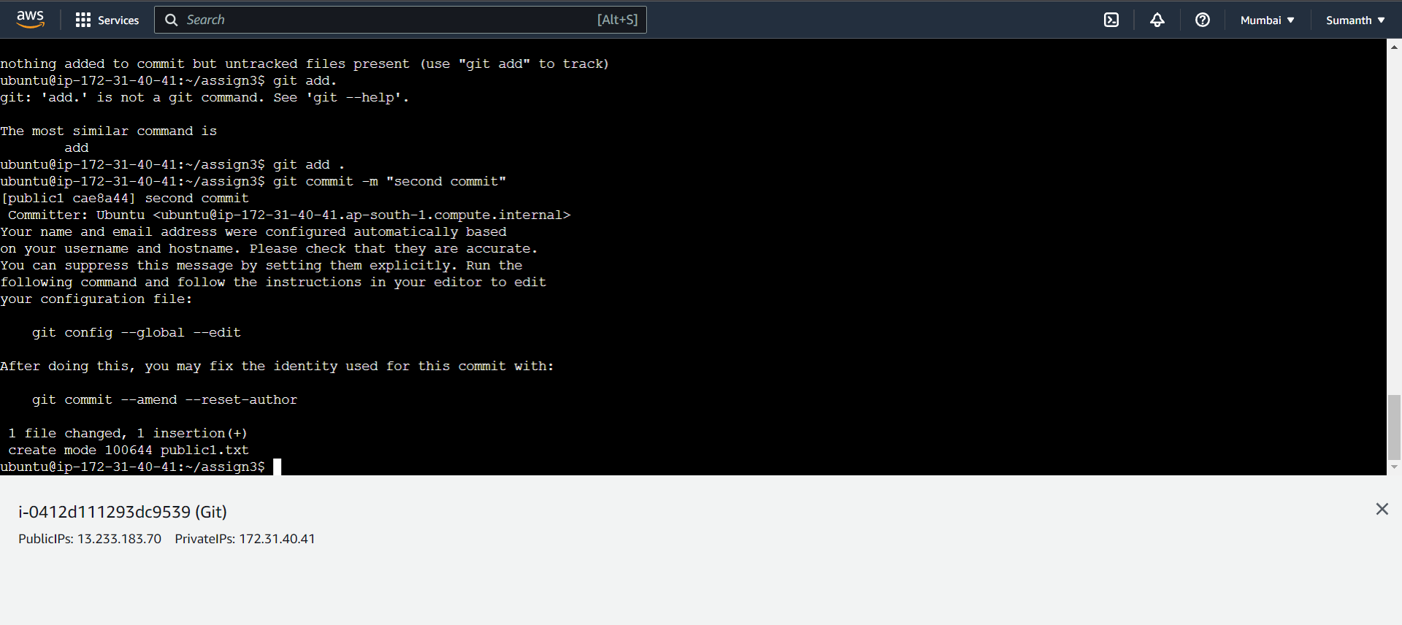

1. Merged public1 on master branch

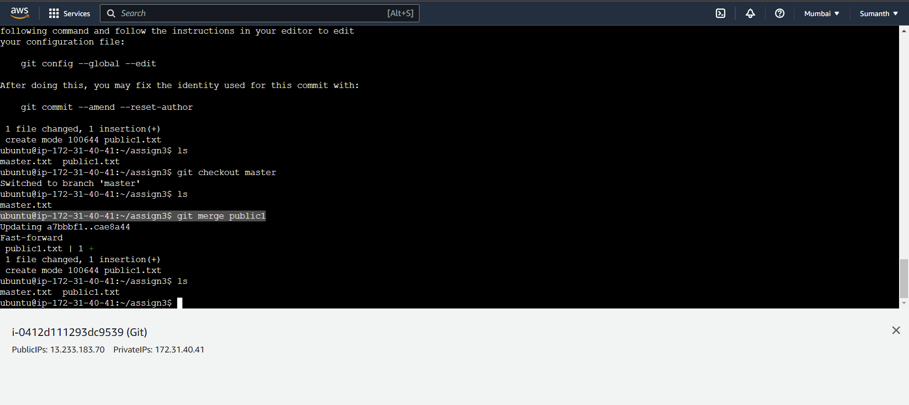

1. Merged public2 on master branch

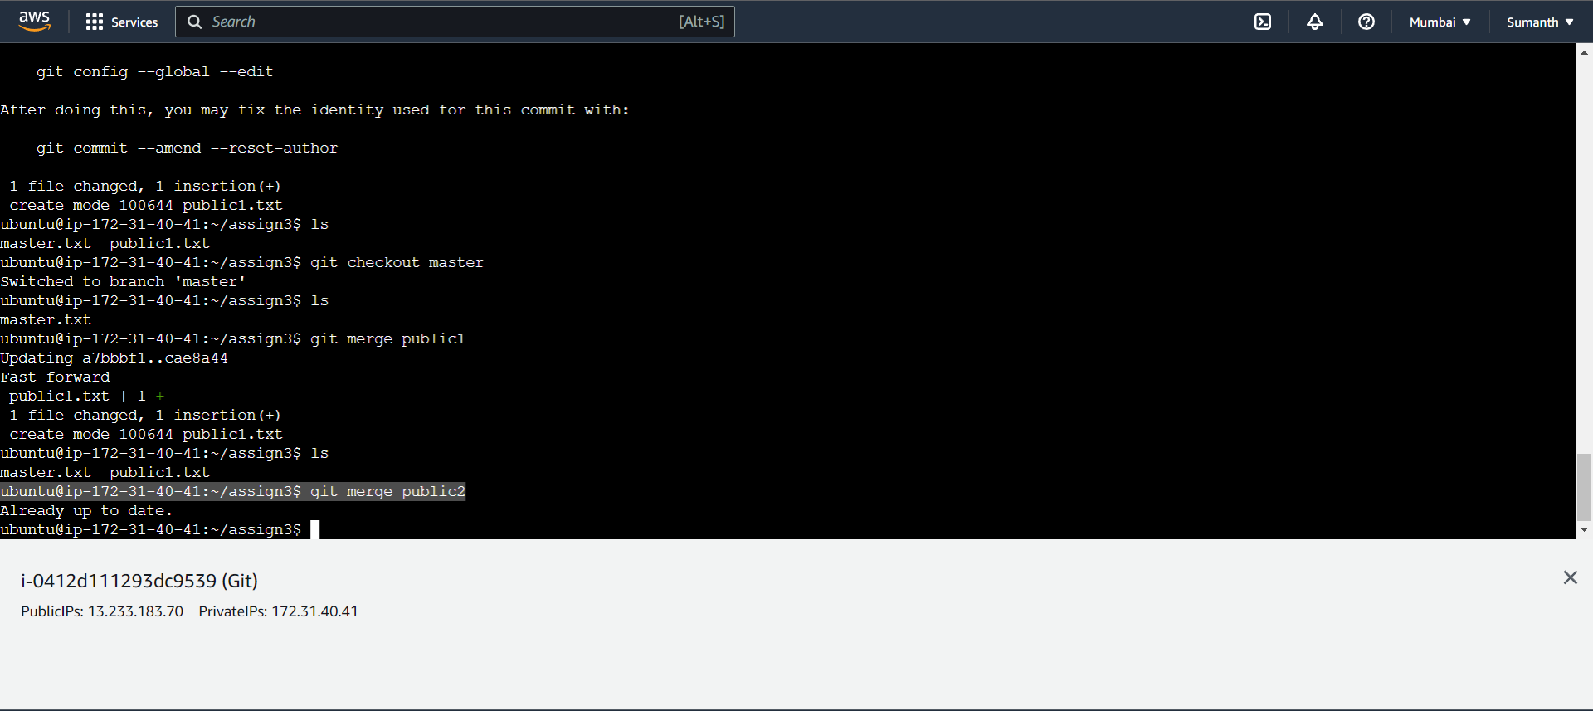

1. Edited master.txt on the private branch, staged and committed

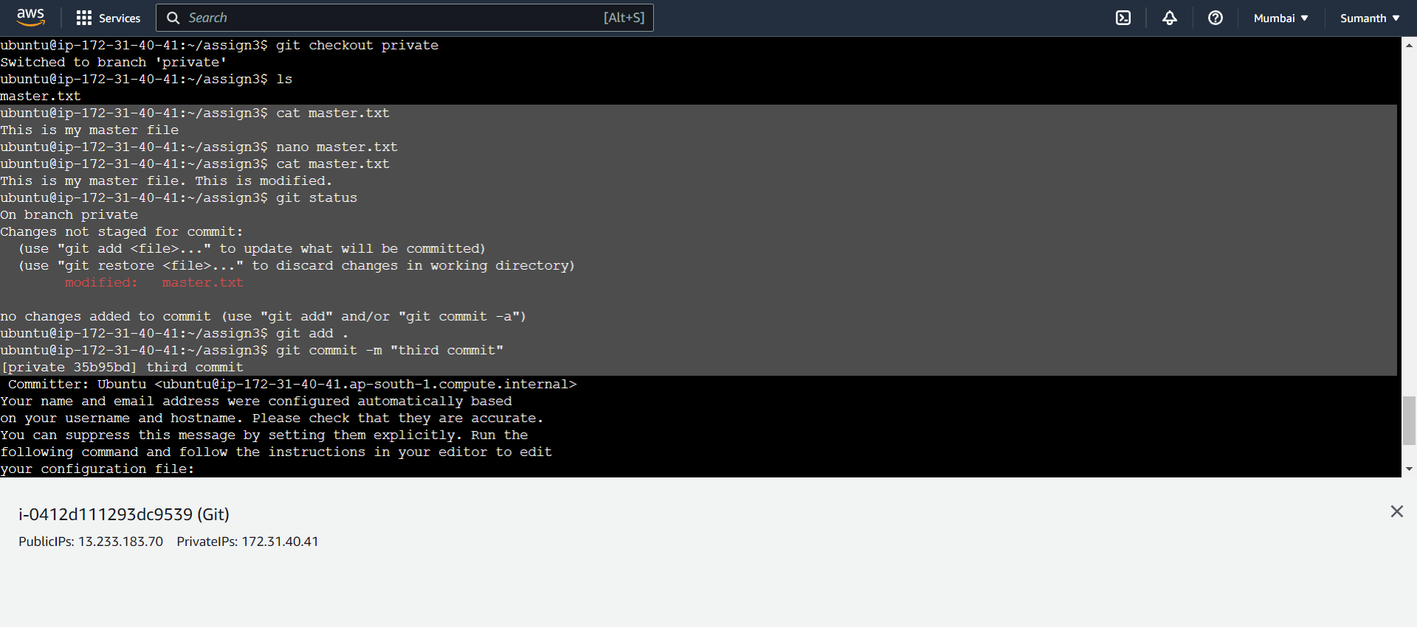

1. Updated public1 branch with updated master.txt file

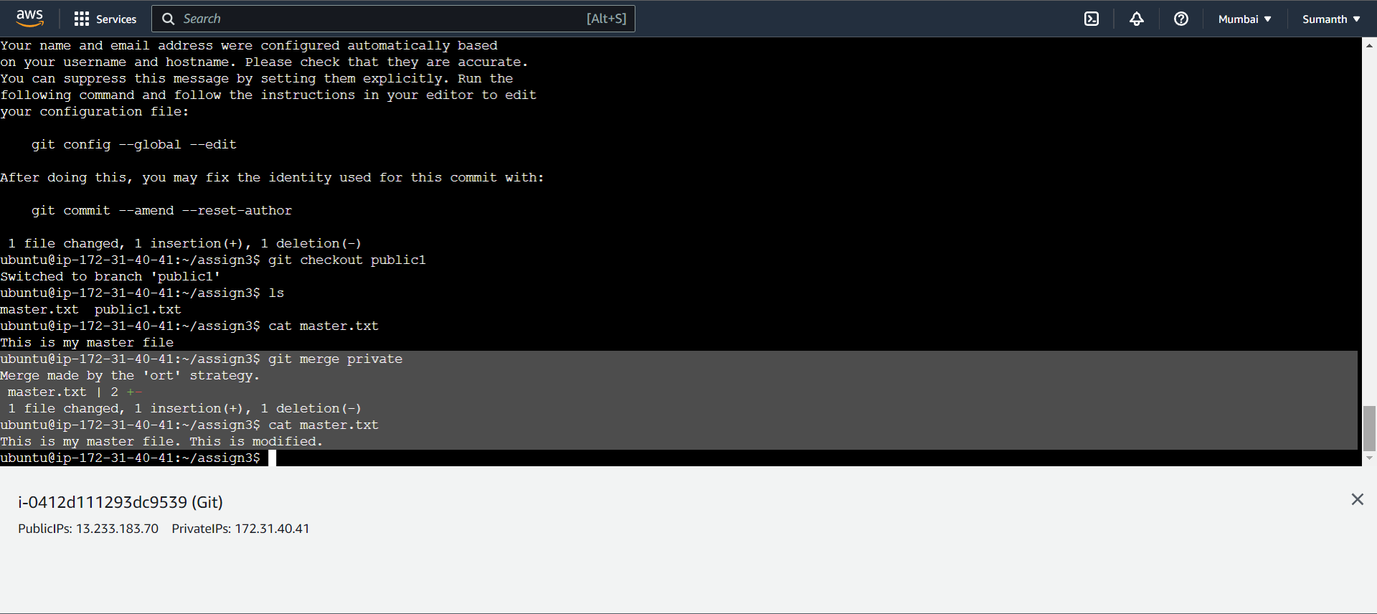

1. Updated public2 branch with updated master.txt file

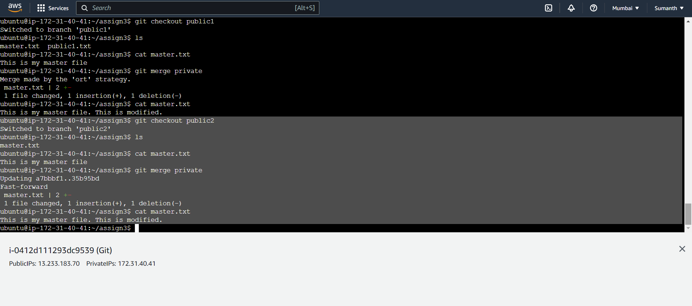

1. Updated new master.txt in master branch

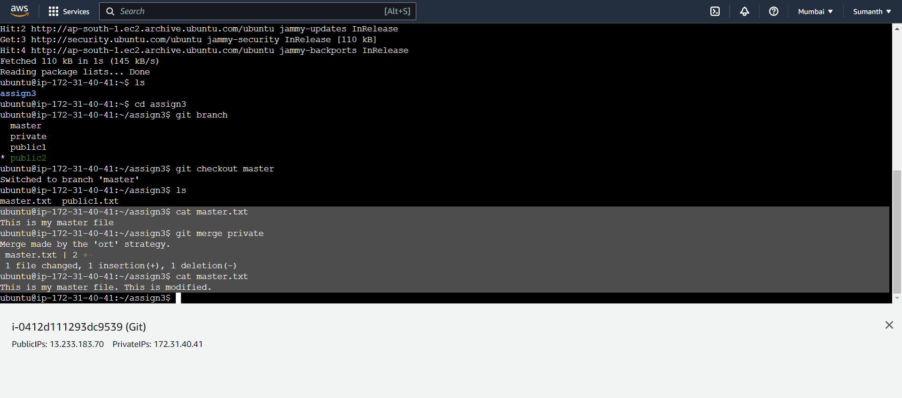

1. Finally updated all the code on the private branch

